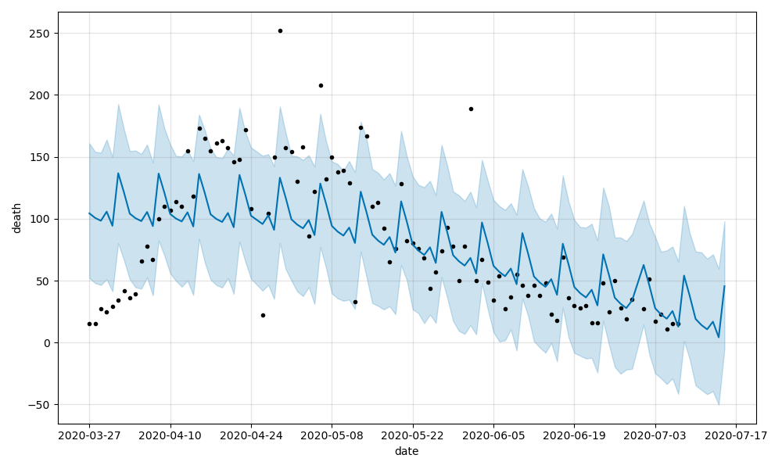
Figure (): univariate time series forecast of the state of Massachusetts before log transformation. Time series plot is represented by the blue line. Most data points (black dots) are distributed near the plot and within the confidence interval (light blue region).

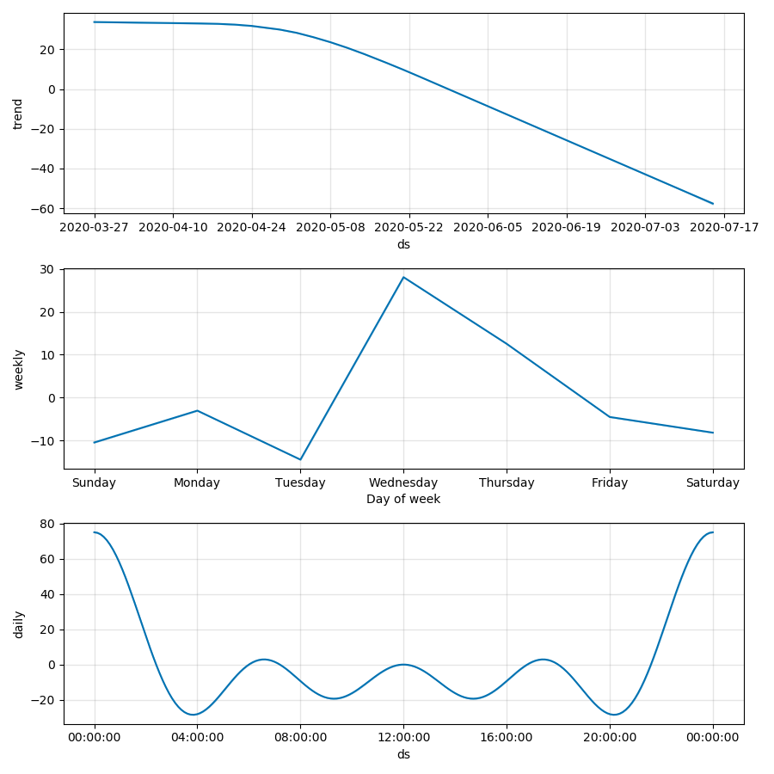
Figure (): the break down of the entire time series plot into 3 components: trend, weekly and daily seasonality. Trend describe the direction of the time series plot is moving towards. Weekly and daily seasonality describes how the trajectory of the time series plot is affected by the daily and weekly trends.

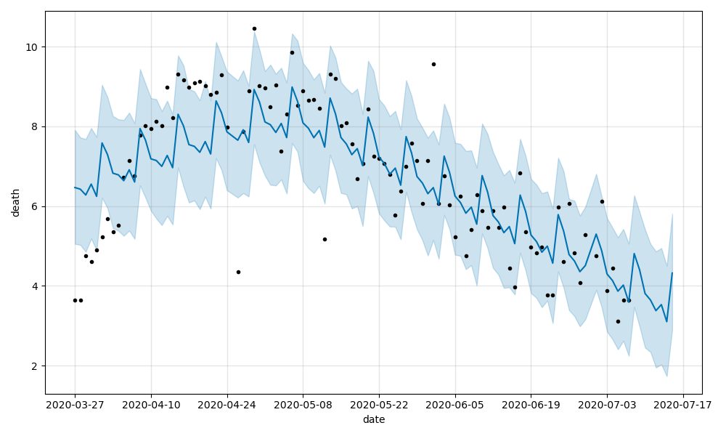
Figure (): univariate time series forecast of the state of Massachusetts after log transformation. The new time series plot bends closer to the data points than before the log transformation. Its confidence interval covers more data points.

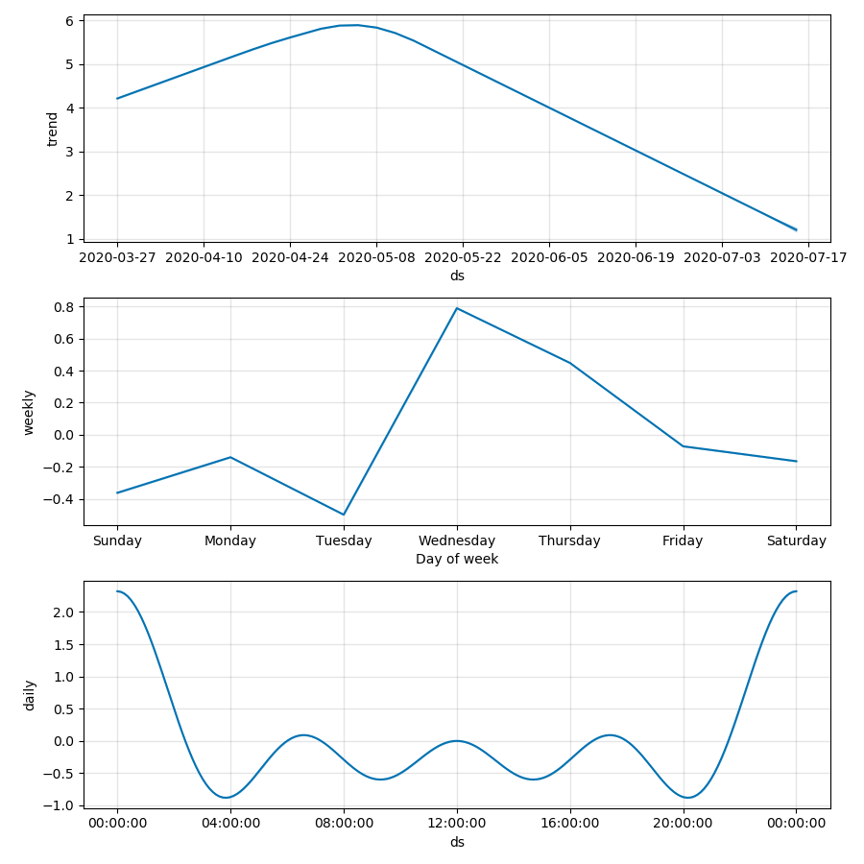
Figure (): Log transformation is a corrective method used to by the prediction model to fit the data better and minimize errors. The components of time series plot are not altered by this parameter tuning technique.

Table(): Evaluation of time series model was done by comparing the training data against the validation data. MAPE is the % error the prediction is from the reality. MAE is the magnitude of that error. More than half of the states (7) responded to log transformation and greatly reduced their prediction errors. Log transformation did not reduce the prediction errors on the other 5 states.

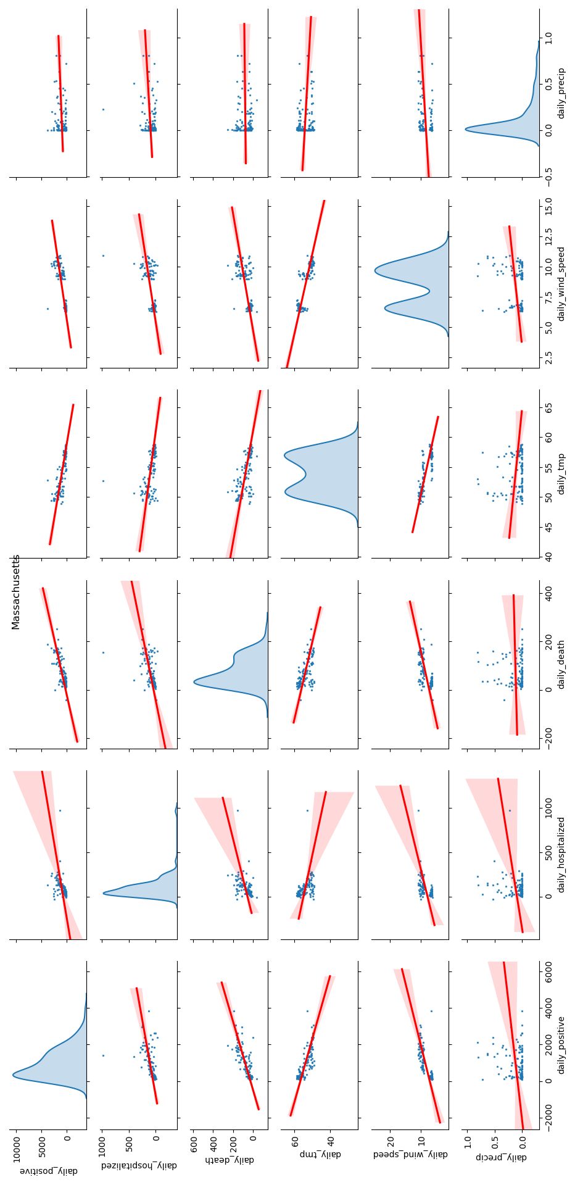

Figure(): scatter matrix plot was used to visualize bivariate relationships between combinations of paired attributes in order to determine how one affects the other. This method was an attempt to construct a set of features for building multivariate time series model. However given the variability of these relationships across the 12 states, no consistent feature set could be built.

